System and Software Architecture Description (SSAD)

Construction Meeting Minutes Application

Team 6

Pradeep Muruganandam - Prototyper and Quality Focal Point
Dennis Evans - System Architect, Project Manager
Pavan Lingambudhi Seshadri Vasan - Requirements Engineer
Sideok You - Feasibility Analyst
Shengyi Chen - Operational Concept Engineer
Nguyen Tran - IIV & V
Qichen Gu - Life Cycle Planner

12/07/2015

Version History
Date | Author | Version | Changes made | Rationale
10/16/15 | DE | 1.0 | - Sections 1 and 2 completed. | - Completed for FCR.
10/16/15 | DE | 1.1 | - Figures updated | - Figures out of date
10/19/15 | DE | 1.2 | - Multiple updates to figures, tables, and text in Sections 1 and 2 | - Updates made based on FCR feedback and input from client.
11/15/15 | DE | 1.2.1 | - Section 2.1.3 Behavior changed to add a process description and course of action for every individual use case. | - Points deducted from FCR package.
11/30/15 | DE | 2.0 | - Sections 4 and 5 added. | - Sections added for DCR.
12/07/15 | DE | 2.1 | - Diagram updates. | - Final updates and finishing touches for DC Package.

Table of Contents
System and Software Architecture Description (SSAD) i
Version History ii
Table of Contents iii
Table of Tables iv
Table of Figures vii
1. Introduction 1
1.1 Purpose of the SSAD 1
1.2 Status of the SSAD 1
2. System Analysis 2
2.1 System Analysis Overview 2
2.2 System Analysis Rationale 22
3. Technology-Independent Model 23
4. Technology-Specific System Design 24
4.1 Design Overview 24
4.2 Design Rationale 34
5. Architectural Styles, Patterns and Frameworks 36

Table of Tables
Table 1: Actors Summary 3
Table 2: Artifacts and Information Summary 4
Table 3: Process Description – Signup 5
Table 4: Typical Course of Action – User Signup 6
Table 5: Alternate Course of Action – Administrator Signup 6
Table 6: Exceptional Course of Action – Failed Signup, Username Already Created 6
Table 7: Exceptional Course of Action – Failed Signup, Invalid Information 7
Table 8: Process Description – User Login 7
Table 9: Typical Course of Action – General User Login 7
Table 10: Alternate Course of Action – Administrator Login 8
Table 11: Exceptional Course of Action – Failed Login 8
Table 12: Process Description – Edit Profile 8
Table 13: Typical Course of Action – Edit Profile 8
Table 14: Exceptional Course of Action – Edit Profile 9
Table 15: Process Description – Approve Signup 9
Table 16: Typical Course of Action – Approve Signup 9
Table 17: Alternate Course of Action – Decline Signup 9
Table 18: Process Description – Create New Project 10
Table 19: Typical Course of Action – Create New Project 10
Table 20: Exceptional Course of Action – Failed to Create New Project 10
Table 21: Process Description – Accept/Reject Comment 11
Table 22: Typical Course of Action – Accepted Comment 11
Table 23: Alternate Course of Action – Rejected Comment 12
Table 24: Process Description – View Pending Tasks 12
Table 25: Typical Course of Action – View Pending Tasks 12
Table 26: Alternate Course of Action – No Pending Tasks 12
Table 27: Process Description – Change Project 13
Table 28: Typical Course of Action – Change Project 13
Table 29: Process Description – Publish Meeting 13
Table 30: Typical Course of Action – Publish Meeting 14
Table 31: Exceptional Course of Action – No Created Meetings 14
Table 32: Process Description – Create Meeting 14
Table 33: Typical Course of Action – Create Meeting 14
Table 34: Exceptional Course of Action – Failed to Create New Meeting 15
Table 35: Process Description – Generate Log 15
Table 36: Typical Course of Action – Generate Log 15
Table 37: Exceptional Course of Action – No Meetings to Generate Log 16
Table 38: Process Description – Edit Meeting 16
Table 39: Typical Course of Action – Edit Meeting 16
Table 40: Exceptional Course of Action – Failed to Edit Meeting 16
Table 41: Process Description – Edit Project 17
Table 42: Typical Course of Action – Edit Project 17
Table 43: Exceptional Course of Action – Failed to Edit Project 17
Table 44: Process Description – View Meeting 18
Table 45: Typical Course of Action – View Meeting 18
Table 46: Exceptional Course of Action – Failed to View Meeting 18
Table 47: Process Description – View Assigned Tasks 18
Table 48: Typical Course of Action – View Assigned Tasks 19
Table 49: Exceptional Course of Action – Failed to View Assigned Tasks 19
Table 50: Process Description – Submit Comment to Assigned Task 19
Table 51: Typical Course of Action – Submit Comment to Assigned Task 20
Table 52: Exceptional Course of Action – Failed to Submit Comment to Assigned Task 20
Table 53: Process Description – View Status of Submitted Comment 20
Table 54: Typical Course of Action – View Status of Submitted Comment 20
Table 55: Exceptional Course of Action – View Status of Submitted Comment 21
Table 56: Process Description – Send Notification 21
Table 57: Typical Course of Action – Send Notification for Assigned Task 21
Table 58: Alternate Course of Action – Send Notification for Submitted Comment 22
Table 59: Hardware Component Description 25
Table 60: Software Component Description 25
Table 61: Design Class Description 28
Table 62: Meeting Management Class Description 29
Table 63: Endpoints Class Description 31
Table 64: Architectural Styles, Patterns, and Frameworks 36

Table of Figures
Figure 1: System Context Diagram 3
Figure 2: Artifacts and Information Diagram 4
Figure 3: Process Diagram – System Use Case 5
Figure 6: Hardware Component Class Diagram 9
Figure 7: Software Component Class Diagram 9
Figure 8: Deployment Diagram 9
Figure 9: Supporting Software Component Class Diagram 9
Figure 10: Design Class Diagram 10
Figure 11: Process Realization Diagram 11
Figure 12: Hardware Component Class Diagram 12
Figure 13: Software Component Class Diagram 12
Figure 14: Deployment Diagram 12
Figure 15: Supporting Software Component Class Diagram 12
Figure 16: Design Class Diagram 13
Figure 17: Process Realization Diagram 13

Introduction

Purpose of the SSAD
The purpose of this SSAD is to document the design of the Construction Meeting Minute application. The SSAD is to be used as a reference for the system architecture as well as an analysis of the design. This SSAD describes how the Construction Meeting Minute application will be developed. In addition, this document should be used as a reference for the future software maintainer to comprehend the design.

Status of the SSAD
-Sections 1 and 2 have been completed for Foundations Commitment Package.
-All other sections will be completed at a later date.
-Naming conventions are likely to change in further revisions (refer to section 2.2 System Analysis Rationale for further details).

System Analysis

System Analysis Overview
The primary purpose of the Meeting Minutes Application is to allow DPW project managers to log meetings and tasks from an Android application while on a construction site. Currently, managers have to log handwritten meeting minutes onsite and then record them into a database when they return to their office. Not only will the Android application save time by allowing managers to log meetings directly from the field, but it will also improve the tracking of meeting minutes. Managers have an administrator account which can assign a “To Do” task from the meeting to one of the general users (e.g. Construction Project Stakeholders - Contractor/Architect) directly from the app. When a general user is assigned to a “To Do” task from the minutes he/she receives a notification on his/her phone that allows him/her to open up the app to view the “To Do” task. When the user completes a “To Do” task from the minutes, he/she can mark it complete in the application which will send a notification to the administrator. Both administrative and general users can view all the meeting minutes and completion statuses through the application.

System Context
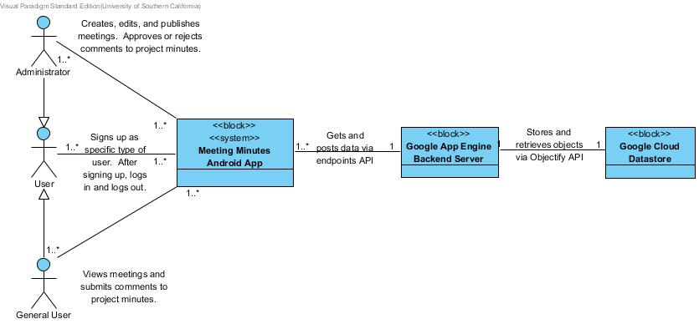
Figure 1: System Context Diagram
Table 1: Actors Summary
Actor | Description | Responsibilities
User | Anyone who uses the Construction Meeting Minutes Android Application. | - Signs up for the application as a specific type of user (Administrator or General User).  - Login to application.  - Logout of application.
Administrator | A special privileged user that manages other users. | - Creates, edits, and publishes meetings.  - Add and remove minutes from meetings.  - Assign minutes, or “To Do” tasks, to general users.  - Monitor minutes “To Do” task status to see if they have been completed or not by the.  - Accepts or rejects task comments.
General User | A non-privileged user that performs tasks directed by the Administrator. | - View meeting minutes.  - Complete “To Do” tasks from the minutes assigned by an Administrator.  - Submits comments to project minutes to report “To Do” task completion.
Google App Engine Backend Server | A backend application hosted by Google App Engine. | - Acts as a server for multiple Android clients.  - Passes data to and from Google Cloud Datastore to Android application.
Google Cloud Datastore | Google cloud storage NoSQL database used to store application data. | - Stores objects to be used by Android application.  - Supports SQL-like queries to retrieve desired data.

Artifacts & Information
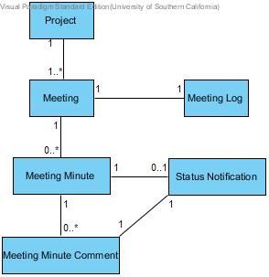
Figure 2: Artifacts and Information Diagram
Table 2: Artifacts and Information Summary
Artifact | Purpose
ATF-1: Project | A project being worked on by the DPW has multiple meetings that are created throughout its course.
ATF-2: Meeting | A meeting contains a description, a date, a meeting number, and an Administrator responsible for the meeting. A meeting is made up of multiple tasks or notes that are referred to as meeting minutes.
ATF-3: Meeting Log | For every meeting, there is a meeting log. The meeting log contains all the minutes that are associated with it.
ATF-4: Meeting Minute | In this context, a meeting minute can be thought of as a task or action item associated with the meeting. The meeting minutes have a description, a date, a meeting number, and potentially an assignee who is responsible for that task. A meeting is typically headed by a project manager, and its deliberations (deliberative assembly of Stakeholders called to debate certain issues and problems, and to take decisions) are recorded in a written form called minutes.
ATF-5: Status Notification | An assignee notification informs the user responsible for the task that a minute has been assigned to him/her. Similarly, when a comment is submitted towards a task, a manager receives a notification.
ATF-6: Meeting Minute Comment | Contains a resolution for the specific meeting minute task. These comments are either approved or rejected by an administrator. Approved comments result in the task being marked as resolved.

Behavior 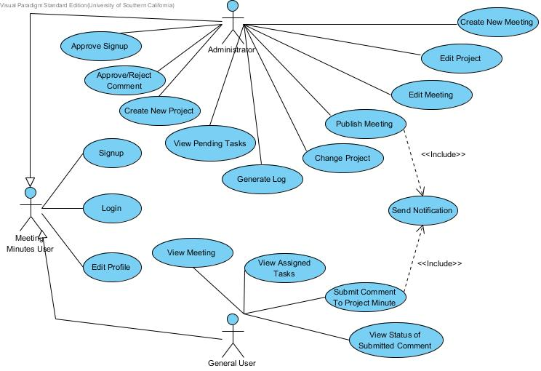
Figure 3: Process Diagram – System Use Case

Track Meeting Minutes

Signup
Table 3: Process Description – Signup
Identifier | UC-1: Signup
Purpose | To sign a user up for a Construction Meeting Minutes account. A user will not be able to access the app until a user’s signup request is approved by an administrator.
Requirements | WC_3516
Development Risks | None.
Pre-conditions | User has downloaded the Construction Meeting Minutes Android application onto their device.
Post-conditions | User information along with their request to signup is submitted to the administrator and is pending approval.

Table 4: Typical Course of Action – User Signup
Seq# | Actor’s Action | System’s Response
1 | [User] Opens the Construction Meeting Minutes Android application. | The app opens up to the login page.
2 | [User] Selects the signup button. | The app opens up to the signup page.
3 | [User] Inputs required information and selects general user for a non-privileged account type. Selects submit. | The app submits the information to be approved by an administrator. Displays message to the user to notify them that they will be able to log in once an administrator approves their signup request.
Table 5: Alternate Course of Action – Administrator Signup
Seq# | Actor’s Action | System’s Response
1 | [User] Opens the Construction Meeting Minutes Android application. | The app opens up to the login page.
2 | [User] Selects the signup button. | The app opens up to the signup page.
3 | [User] Inputs required information and selects administrator for a privileged account type. Selects submit. | The app submits the information to be approved by an administrator. Displays message to the user to notify them that they will be able to log in once an administrator approves their signup request.
Table 6: Exceptional Course of Action – Failed Signup, Username Already Created
Seq# | Actor’s Action | System’s Response
1 | [User] Opens the Construction Meeting Minutes Android application. | The app opens up to the login page.
2 | [User] Selects the signup button. | The app opens up to the signup page.
3 | [User] Inputs required information and selects general user for a non-privileged account type. Selects submit. | The app displays an error saying that an account with that username has already been created. User must change their username and re-submit.
Table 7: Exceptional Course of Action – Failed Signup, Invalid Information
Seq# | Actor’s Action | System’s Response
1 | [User] Opens the Construction Meeting Minutes Android application. | The app opens up to the login page.
2 | [User] Selects the signup button. | The app opens up to the signup page.
3 | [User] Inputs required information and selects general user for a non-privileged account type. Selects submit. | The app displays an error notifying the user of the invalid information. User must correct and re-submit.

Login
Table 8: Process Description – User Login
Identifier | UC-2: Login
Purpose | To determine if a user has the necessary credentials to log into the system as either a privileged (administrator) or non-privileged (general user) user.
Requirements | WC_3516
Development Risks | None.
Pre-conditions | User already has an account registered as a normal user or privileged user.
Post-conditions | Administrator Course of Action:  Administrator is able to log into privileged user account where they can select a project to take them to the administrator’s dashboard.  General User Course of Action:  User is able to log into a non-privileged account which takes them to the general user dashboard.

Table 9: Typical Course of Action – General User Login
Seq# | Actor’s Action | System’s Response
1 | [User] Opens the Construction Meeting Minutes Android application. | The app opens up to the login page.
2 | [User] Enters username and password belonging to a non-privileged account. | Verifies login information. User is taken to the general user dashboard.
Table 10: Alternate Course of Action – Administrator Login
Seq# | Actor’s Action | System’s Response
1 | [User] Opens the Construction Meeting Minutes Android application. | The app opens up to the login page.
2 | [Administrator] Enters username and password belonging to a privileged account. | Verifies login information. Administrator is taken to select a project page.
3 | [Administrator] Selects their current project. | Administrator is taken to the administrator dashboard.
Table 11: Exceptional Course of Action – Failed Login
Seq# | Actor’s Action | System’s Response
1 | [User] Opens the Construction Meeting Minutes Android application. | The app opens up to the login page.
2 | [User] Enters username and password that do not belong to an account. | Unable to verify login information. Displays error message notifying the user of an incorrect username or password.

Edit Profile
Table 12: Process Description – Edit Profile
Identifier | UC-3: Edit Profile
Purpose | To allow a user to edit information about himself.
Requirements | WC_3776
Development Risks | None.
Pre-conditions | User is logged into a privileged or non-privileged account and is on the respective dashboard.
Post-conditions | User account information is updated based.

Table 13: Typical Course of Action – Edit Profile
Seq# | Actor’s Action | System’s Response
1 | [User] Selects the edit profile option. | The app displays the edit profile screen.
2 | [User] Inputs desired information and selects the update option. | The app verifies the inputs and then updates the user’s account information.
Table 14: Exceptional Course of Action – Edit Profile
Seq# | Actor’s Action | System’s Response
1 | [User] Selects the edit profile option. | The app displays the edit profile screen.
2 | [User] Inputs desired information and selects the update option. | The app attempts to verify the inputs. Error regarding invalid information is displayed to the user.

Approve Signup
Table 15: Process Description – Approve Signup
Identifier | UC-4: Approve Signup
Purpose | To sign a user up for a Construction Meeting Minutes account. A user will not be able to access the app until a user’s signup request is approved by an administrator.
Requirements | WC_3775
Development Risks | None.
Pre-conditions | User has logged in to a privileged account and is on the administrator’s dashboard screen.
Post-conditions | User requesting account access can now log in.

Table 16: Typical Course of Action – Approve Signup
Seq# | Actor’s Action | System’s Response
1 | [Administrator] Selects the approve signup option that is viewable on the administrator’s dashboard. | The app displays the approve signup screen.
2 | [Administrator] Selects a signup request. | The app displays request details such as user info and account type
3 | [Administrator] Chooses to approve signup request. | The requesting user can now log into the application.
Table 17: Alternate Course of Action – Decline Signup
Seq# | Actor’s Action | System’s Response
1 | [Administrator] Selects the approve signup option that is viewable on the administrator’s dashboard. | The app displays the approve signup screen.
2 | [Administrator] Selects a signup request. | The app displays request details such as user info and account type
3 | [Administrator] Chooses to decline signup request. | The requesting user cannot log into the application.

Create New Project
Table 18: Process Description – Create New Project
Identifier | UC-5: Create New Project
Purpose | To allow an administrator to start a new project for which to track meetings for.
Requirements | WC_3780
Development Risks | None.
Pre-conditions | User has logged in to a privileged account and is on the administrator’s dashboard screen.
Post-conditions | New project is created and available for which administrators are able to track and organize meetings.

Table 19: Typical Course of Action – Create New Project
Seq# | Actor’s Action | System’s Response
1 | [Administrator] Selects the create a new project option that is viewable on the administrator’s dashboard. | The app displays the create a project screen.
2 | [Administrator] Enters project information and default attendee list which will automatically be rolled into a meetings attendee list when a meeting is created. Administrator then selects create. | Verifies default attendee list contains valid users. Creates a project that is now available for administrator’s to select from the choose a project screen.
Table 20: Exceptional Course of Action – Failed to Create New Project
Seq# | Actor’s Action | System’s Response
1 | [Administrator] Selects the create a new project option that is viewable on the administrator’s dashboard. | The app displays the create a project screen.
2 | [Administrator] Enters project information and default attendee list which will automatically be rolled into a meetings attendee list when a meeting is created. Administrator then selects create. | Attempts to verify that the default attendee list contains valid users. Android toast notifies administrator of user(s) that is/are not valid. New project is not created.

Accept/Reject Comment
Table 21: Process Description – Accept/Reject Comment
Identifier | UC-6: Accept/Reject Comment
Purpose | To accept or reject comments that have been submitted by users for specific tasks.
Requirements | WC_3778
Development Risks | None.
Pre-conditions | User has logged in to a privileged account and is on the administrator’s dashboard screen. A meeting has been created in the current project for which an assigned user has submitted a comment regarding his specific task.
Post-conditions | Administrator accepts the comment:  The task status for which the comment was accepted changes from pending to complete. That task will not be rolled into subsequent meetings.  Administrator rejects the comment:  Comment status reflects it has been rejected. Task status is still pending and will be rolled into subsequent meetings.

Table 22: Typical Course of Action – Accepted Comment
Seq# | Actor’s Action | System’s Response
1 | [Administrator] Selects the view submitted comments option that is viewable on the administrator’s dashboard. | The app displays the view submitted comments screen.
2 | [Administrator] Selects a comment to view. | Comment is displayed along with the assignee that submitted it. System gives option to accept or reject the comment.
3 | [Administrator] Presses the accept comment button. | Comment is accepted. Task status changes from pending to complete and will not be rolled into subsequent meetings.
Table 23: Alternate Course of Action – Rejected Comment
Seq# | Actor’s Action | System’s Response
1 | [Administrator] Selects the view submitted comments option that is viewable on the administrator’s dashboard. | The app displays the view submitted comments screen.
2 | [Administrator] Selects a comment to view. | Comment is displayed along with the assignee that submitted it. System gives option to accept or reject the comment.
3 | [Administrator] Presses the reject comment button. | Comment is rejected. Task status still reflects pending and will be rolled into subsequent meetings.

View Pending Tasks
Table 24: Process Description – View Pending Tasks
Identifier | UC-7: View Pending Tasks
Purpose | To allow an administrator to view all pending tasks for the current project.
Requirements | WC_3712
Development Risks | None.
Pre-conditions | User has logged in to a privileged account and is on the administrator’s dashboard screen.
Post-conditions | All unresolved tasks are displayed for the administrator’s viewing.

Table 25: Typical Course of Action – View Pending Tasks
Seq# | Actor’s Action | System’s Response
1 | [Administrator] Chooses the option to view pending tasks from the administrator’s dashboard. | The app displays the view pending tasks screen.
2 | [Administrator] Selects a task. | Displays tasks details and assignee.
Table 26: Alternate Course of Action – No Pending Tasks
Seq# | Actor’s Action | System’s Response
1 | [Administrator] Chooses the option to create a new project from the administrator’s dashboard. | The app displays empty view pending tasks screen since no pending tasks exist.

Change Project
Table 27: Process Description – Change Project
Identifier | UC-8: Change Project
Purpose | To allow an administrator account to change the project that they are currently managing.
Requirements | WC_3713, WC_3777
Development Risks | None.
Pre-conditions | User has logged in to a privileged account and at least one other project exist
Post-conditions | Administrator is taken to the dashboard screen for the selected project.

Table 28: Typical Course of Action – Change Project
Seq# | Actor’s Action | System’s Response
1 | [Administrator] Selects settings button from the Android toolbar. | Dropdown settings menu is displayed.
2 | [Administrator] Selects change project option. | The app displays the select a project screen.
3 | [Administrator] Chooses project. | The app displays the administrator’s dashboard screen which shows options relevant to the selected project.

Publish Meeting
Table 29: Process Description – Publish Meeting
Identifier | UC-9: Publish Meeting
Purpose | Publish meeting feature makes a recently created meeting on an administrator’s device viewable to other users.
Requirements | WC_3514
Development Risks | None.
Pre-conditions | User has logged in to a privileged account and is on the administrator’s dashboard screen. Administrator has already created a meeting that is waiting to be published.
Post-conditions | New meeting is published and accessible by other users.

Table 30: Typical Course of Action – Publish Meeting
Seq# | Actor’s Action | System’s Response
1 | [Administrator] Chooses the option to publish meeting from the administrator’s dashboard. | The app displays the publish meeting screen.
2 | [Administrator] Chooses a created meeting for which to publish and then selects the publish button. | Meeting is published and accessible to other administrators and users on the attendee list. Users on the attendee list receive an in app notification informing them that a meeting has been created.
Table 31: Exceptional Course of Action – No Created Meetings
Seq# | Actor’s Action | System’s Response
1 | [Administrator] Chooses the option to publish meeting from the administrator’s dashboard. | The app displays empty publish meeting screen since no created meetings exist.

Create Meeting
Table 32: Process Description – Create Meeting
Identifier | UC-10: Create Meeting
Purpose | To create a new meeting for a project for which an administrator can add minutes to and assign tasks to attendees.
Requirements | WC_3713
Development Risks | None.
Pre-conditions | User has logged in to a privileged account and is on the administrator’s dashboard screen for the project they wish to create a meeting for.
Post-conditions | New meeting is created with all pending tasks rolled in from the previous meeting belonging to the same meeting category. The meeting is only accessible on the administrator’s device until it is published.

Table 33: Typical Course of Action – Create Meeting
Seq# | Actor’s Action | System’s Response
1 | [Administrator] Selects the create a meeting option that is viewable on the administrator’s dashboard. | The app displays the create a meeting screen. Attendee list shows the default attendees for that project. Pending tasks from previous meeting are shown in the task list.
2 | [Administrator] Enters meeting information and attendee list. Administrator inputs additional meeting minutes. | Verifies attendee list contains valid users. Creates a meeting with the entered information. The newly created meeting is only available on the administrator’s device.
Table 34: Exceptional Course of Action – Failed to Create New Meeting
Seq# | Actor’s Action | System’s Response
1 | [Administrator] Selects the create a meeting option that is viewable on the administrator’s dashboard. | The app displays the create a meeting screen. Attendee list shows the default attendees for that project. Pending tasks from previous meeting are shown in the task list.
2 | [Administrator] Enters meeting information and attendee list. Administrator inputs additional meeting minutes. | Attempts to verify attendee list contains valid users. Android toast notifies administrator of user(s) that is/are not valid. New meeting is not created.

Generate Log
Table 35: Process Description – Generate Log
Identifier | UC-11: Generate Log
Purpose | To allow an administrator to export a meeting and its minutes for the current project into pdf format on the android device.
Requirements | WC_3707, WC_3782
Development Risks | Formatting the exported PDF could be a challenge for developers.
Pre-conditions | User has logged in to a privileged account and is on the administrator’s dashboard screen. Administrator has already created a meeting that they desire to export to PDF format.
Post-conditions | Meeting is saved in pdf format on the administrator’s Android device.

Table 36: Typical Course of Action – Generate Log
Seq# | Actor’s Action | System’s Response
1 | [Administrator] Chooses the option to generate meeting log from the administrator’s dashboard. | The app displays the generate meeting screen which displays meetings in the current project.
2 | [Administrator] Chooses a meeting from the list to export and then selects the export button. | Meeting is saved on the administrator’s android device in PDF format.
Table 37: Exceptional Course of Action – No Meetings to Generate Log
Seq# | Actor’s Action | System’s Response
1 | [Administrator] Chooses the option to generate meeting log from the administrator’s dashboard. | The app displays the generate meeting screen which displays an error message notifying the user that there are no meetings for the current project.

Edit Meeting
Table 38: Process Description – Edit Meeting
Identifier | UC-12: Edit Meeting
Purpose | To edit a meeting that has been created. Editing includes altering the attendee list, date, and meeting minutes.
Requirements | WC_3777
Development Risks | None.
Pre-conditions | User has logged in to a privileged account and is on the administrator’s dashboard screen for the project they wish to edit a meeting for. Meeting has already been created.
Post-conditions | Meeting gets edited and reflects changes that the administrator has made.

Table 39: Typical Course of Action – Edit Meeting
Seq# | Actor’s Action | System’s Response
1 | [Administrator] Selects the edit meeting option that is viewable on the administrator’s dashboard. | The app displays the edit meeting screen that shows the meeting information.
2 | [Administrator] Alters desired meeting information and selects submit. | Verifies attendee list contains valid users. Applies the edits entered to the meeting.
Table 40: Exceptional Course of Action – Failed to Edit Meeting
Seq# | Actor’s Action | System’s Response
1 | [Administrator] Selects the edit meeting option that is viewable on the administrator’s dashboard. | The app displays the edit meeting screen that shows the meeting information.
2 | [Administrator] Alters desired meeting information and selects submit. | Attempts to verify attendee list contains valid users. Android toast notifies administrator of user(s) that is/are not valid. Edits to the meeting are not applied.

Edit Project
Table 41: Process Description – Edit Project
Identifier | UC-13: Edit Meeting
Purpose | To edit a project that has been created.
Requirements | WC_3781
Development Risks | None.
Pre-conditions | User has logged in to a privileged account and is on the administrator’s dashboard screen for the project they wish to edit.
Post-conditions | Project gets edited and reflects changes that the administrator has made.

Table 42: Typical Course of Action – Edit Project
Seq# | Actor’s Action | System’s Response
1 | [Administrator] Selects the edit project option that is viewable on the administrator’s dashboard. | The app displays the edit project screen that shows the meeting information.
2 | [Administrator] Alters desired project information and selects submit. | Verifies default user list contains valid users. Applies the edits entered to the project.
Table 43: Exceptional Course of Action – Failed to Edit Project
Seq# | Actor’s Action | System’s Response
1 | [Administrator] Selects the edit project option that is viewable on the administrator’s dashboard. | The app displays the edit project screen that shows the meeting information.
2 | [Administrator] Alters desired project information and selects submit. | Attempts to verify default user list contains valid users. Android toast notifies administrator of user(s) that is/are not valid. Edits to the project are not applied.

View Meeting
Table 44: Process Description – View Meeting
Identifier | UC-14: View Meeting
Purpose | Allows non-privileged users to view meetings for which they are part of the attendee list.
Requirements | WC_3696
Development Risks | None.
Pre-conditions | User has logged in to a non-privileged account and is on the dashboard screen. Meeting has already been created with the user belonging to the attendee list.
Post-conditions | Meeting and minutes are displayed on the attendee’s device.

Table 45: Typical Course of Action – View Meeting
Seq# | Actor’s Action | System’s Response
1 | [User] Selects the view meeting option that is viewable on the dashboard. | App shows meetings for which the user is listed on the attendee list.
2 | [User] Selects the desired meeting to view. | The app displays the view meeting screen that shows the meeting information.
Table 46: Exceptional Course of Action – Failed to View Meeting
Seq# | Actor’s Action | System’s Response
1 | [User] Selects the view meeting option that is viewable on the dashboard. | User is not on the attendee list for the project so the app displays a no meetings to view message.

View Assigned Tasks
Table 47: Process Description – View Assigned Tasks
Identifier | UC-15: View Assigned Tasks
Purpose | Allows non-privileged users to view meeting minutes that have been assigned for them to complete.
Requirements | WC_3712
Development Risks | None.
Pre-conditions | User has logged in to a non-privileged account and is on the dashboard screen. Meeting has already been created with the user belonging to the attendee list.
Post-conditions | All pending tasks that have been assigned to the user for the current project are displayed.

Table 48: Typical Course of Action – View Assigned Tasks
Seq# | Actor’s Action | System’s Response
1 | [User] Selects the view assigned tasks option that is viewable on the dashboard. | App displays assigned task screen which shows all the pending minutes that are assigned to the user for the current project.
Table 49: Exceptional Course of Action – Failed to View Assigned Tasks
Seq# | Actor’s Action | System’s Response
1 | [User] Selects the view assigned tasks option that is viewable on the dashboard. | User does not have any pending assigned tasks for the current project so the app displays a message informing the user that there are no assigned tasks to view.

Submit Comment to Assigned Task
Table 50: Process Description – Submit Comment to Assigned Task
Identifier | UC-16: Submit Comment to Assigned Task
Purpose | Allows non-privileged to submit comments for meeting minutes that have been assigned to them. When a submitted comment is approved by an administrator that task status changes from pending to complete.
Requirements | WC_3517, WC_3698
Development Risks | None.
Pre-conditions | User has logged in to a non-privileged account and is on the view assigned tasks screen. Meeting has already been created with the user belonging to the attendee list. A task has been assigned to the current user with a status of pending.
Post-conditions | Comment is submitted to administrator for the specific task. If approved by the administrator, the task status changes from pending to complete.

Table 51: Typical Course of Action – Submit Comment to Assigned Task
Seq# | Actor’s Action | System’s Response
1 | [User] Selects assigned task for which they are submitting a comment for from the view assigned task screen. | App opens text box for user to input comment.
2 | [User] Inputs comment for selected task and selects submit. | Sends notification to administrator notifying them that a user has submitted a comment for a task.
Table 52: Exceptional Course of Action – Failed to Submit Comment to Assigned Task
Seq# | Actor’s Action | System’s Response
1 | [User] Selects assigned task for which they are submitting a comment for from the view assigned task screen. | App opens text box for user to input comment.
2 | [User] Inputs comment for selected task and selects submit. | Displays error message that the comment is too long.

View Status of Submitted Comment
Table 53: Process Description – View Status of Submitted Comment
Identifier | UC-17: View Status of Submitted Comment
Purpose | Allows non-privileged to view the status of their submitted comment for an assigned task. If an administrator accepts a comment then the task status changes to accepted. If the comment is declined then the assignee must resubmit.
Requirements | WC_3696
Development Risks | None.
Pre-conditions | User has logged in to a non-privileged account and is on the dashboard screen. Meeting has already been created with the user belonging to the attendee list. A task has been assigned to the current user with a status of pending. User has submitted a comment for an assigned task.
Post-conditions | Comments submitted by the user are displayed along with their status.

Table 54: Typical Course of Action – View Status of Submitted Comment
Seq# | Actor’s Action | System’s Response
1 | [User] Selects view status of submitted comments from the dashboard screen. | View status of submitted comments screen appears and displays submitted comments along with their status.
Table 55: Exceptional Course of Action – View Status of Submitted Comment
Seq# | Actor’s Action | System’s Response
1 | [User] Selects view status of submitted comments from the dashboard screen. | View status of submitted comments screen opens and displays a message informing the user that they have not submitted any comments.

Send Notification
Table 56: Process Description – Send Notification
Identifier | UC-18: Send Notification
Purpose | To notify a general user that a meeting has been published with a task assigned to them. Also, notifications alert managers that a comment has been submitted for a specific task.
Requirements | N/A
Development Risks | Unfamiliarity with Parse Push messaging.
Pre-conditions | Administrator Course:  Administrative user has just published a meeting with a task assigned to a general user.  General User Course:  General user has just submitted a comment towards an assigned task.
Post-conditions | Administrator Course:  General user(s) that have been assigned a task receive a Parse Push notification to alert them.  General User Course:  Administrative user receives a parse push notification to alert them that a comment has been submitted toward a specific task.

Table 57: Typical Course of Action – Send Notification for Assigned Task
Seq# | Actor’s Action | System’s Response
1 | [Administrator] Publishes a meeting with at least one task assigned to an attendee. | Publishes meeting and sends a Parse Push notification to task assignees.
Table 58: Alternate Course of Action – Send Notification for Submitted Comment
Seq# | Actor’s Action | System’s Response
1 | [General User] Submits a comment to an assigned task. | Adds comment to the minute and sends a Parse Push notification to administrative users.

Modes of Operation

The Construction Meeting Minutes application operates in a single mode, therefore no further analysis is needed.

System Analysis Rationale
The nomenclature used in the version of this document presented with the FC package was a bit confusing. Specifically the naming conventions for types of users, meetings, and their minutes was inconsistent. As a result, improvements have been made in the current version of the SSAD. Privileged users, which were previously referred to as managers, are called administrators. Non privileged users, which were previously called employees, contractors, or architects, are now called general users. In the case of the process descriptions for each use case, a third label is used. This “User” label is generic and refers to both administrators and general users. As for meeting minutes, a meeting contains multiple notes which are called minutes. If a minute has an assignee then it requires some action and is referred to as a to do item or task.

Technology-Independent Model
This section has been intentionally omitted. Please refer to the technology-specific design is documented in the next section. The technology-independent model would be redundant and useless for our technology-dependent system. Furthermore, the technology-independent model can easily be derived from the technology-dependent model.

Technology-Specific System Design

Design Overview

System Structure
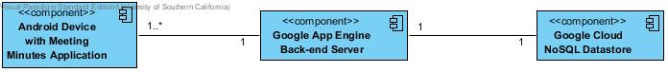Figure 4: Hardware Component Class Diagram

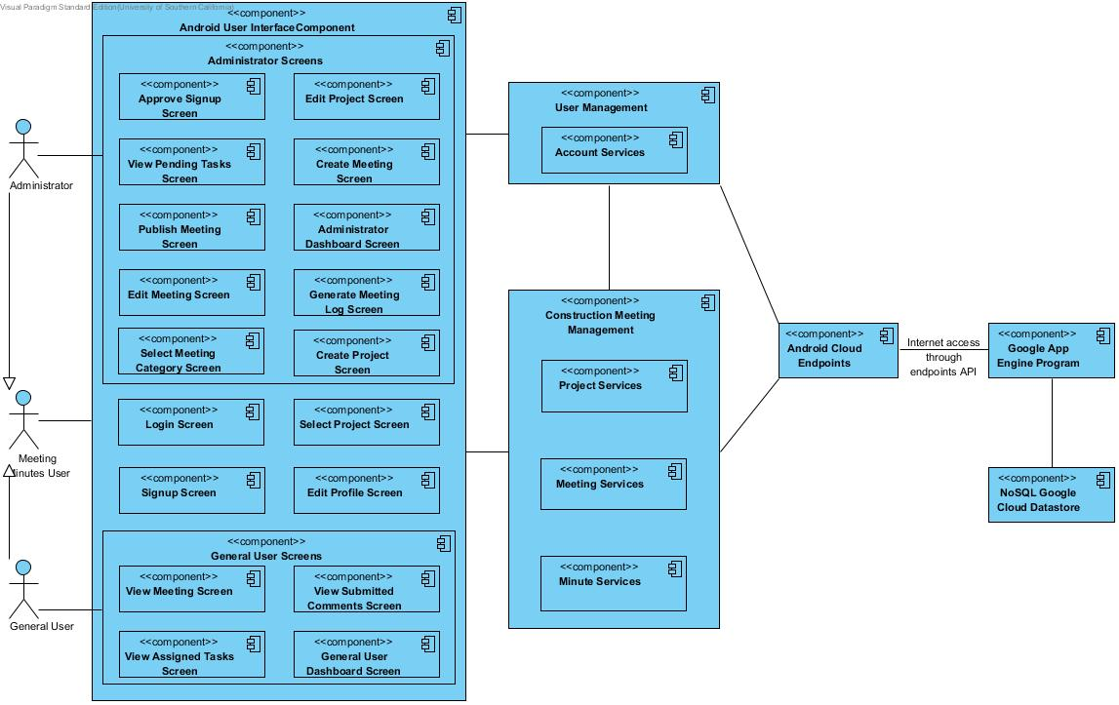
Figure 5: Software Component Class Diagram

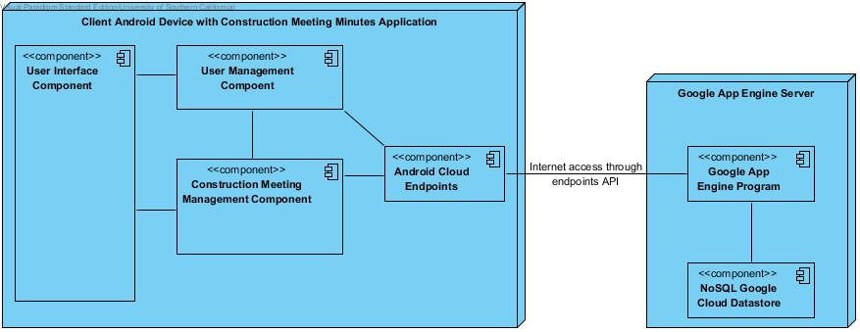Figure 6: Deployment Diagram

Table 59: Hardware Component Description
Hardware Component | Description
Android Device | The user’s mobile phone or Android tablet with the Construction Meeting Minutes application installed.
Google App Engine Back-end Server | The Google App Engine Server component services requests from all client Android devices. This component acts as a bridge between the Android devices and the application data that is stored in the cloud.
Google Cloud NoSQL Datastore | The Google Cloud Datastore is where the applications data is stored. Data such as user info, project info, meetings, and minutes are stored and retrieved from the cloud datastore by the Construction Meeting Minutes application.

Table 60: Software Component Description
Software Component | Description
Approve Signup Screen | This component is a user interface screen that is only available to administrative users. It can be accessed from the administrator dashboard and allows administrators to approve or decline signup requests.
View Pending Tasks Screen | This component is a user interface screen that is only available to administrative users. It can be accessed from the administrator dashboard and allows an administrator to view all pending tasks for the current project.
Publish Meeting Screen | This component is a user interface screen that is only available to administrative users. After an administrator creates a meeting, it is not yet viewable to other users until it is published. This screen can be accessed from the administrator dashboard and allows an administrator to publish a meeting.
Edit Meeting Screen | This component is a user interface screen that is only available to administrative users. It allows administrators to view a meeting in the current project and/or edit its details.
Select Meeting Category Screen | This component is a user interface screen that is only available to administrative users. When an administrator chooses to create a new meeting from the project dashboard, this screen is displayed to select the meeting type before the create new meeting screen is shown.
Edit Project Screen | This component is a user interface screen that is only available to administrative users. It is accessible from the project dashboard and allows administrators to edit details of the current project.
Create Meeting Screen | This component is a user interface screen that is only available to administrative users. It is accessible from the project dashboard after a meeting category has been selected and allows administrators to create a meeting for the current project.
Administrator Dashboard Screen | This component is a user interface screen that is only available to administrative users. It displays administrator options for the currently selected project.
Generate Meeting Log Screen | This component is a user interface screen that is only available to administrative users. It allows an administrator to generate a pdf version of the meeting log which will be saved on the administrator’s device.
Create Project Screen | This component is a user interface screen that is only available to administrative users. It can be accessed from the administrator dashboard to create a new project for which to track meetings for.
Login Screen | This component is a user interface screen that is available to all users. It allows a user to login to their account for the Construction Meeting Minutes application.
Signup Screen | This component is a user interface screen that is available to all users. It can be accessed from the login screen and it allows a user to request access to the application.
Select Project Screen | This component is a user interface screen that is available to all users. This screen is shown after a user logs in. A user must select a project to take them to their dashboard which displays options relevant to the selected project.
Edit Profile Screen | This component is a user interface screen that is available to all users. It allows a user to edit or update personal information.
View Meeting Screen | This component is a user interface screen that is available to general users. This screen allows a general user to view a meeting for which he/she is included in the attendee list.
View Assigned Tasks Screen | This component is a user interface screen that is available to general users. This screen displays tasks that have been assigned to the user. From here, a user can submit a comment regarding his task.
View Submitted Comments Screen | This component is a user interface screen that is available to general users. It allows them to view comments that they have submitted for assigned tasks. This page also lets the user know the status of their submitted comment by showing whether or not it was accepted by an administrator.
General User Dashboard Screen | This component is a user interface screen that is available to general users. It displays general user options for the currently selected project.
Account Services | This component is responsible for managing user accounts. Functionality such as login, logout, signup, and editing a user profile is done here.
Project Services | This component is responsible for managing projects. It contains the project controller which allows an administrator to create a new project or update an existing one.
Meeting Services | This component is responsible for managing meetings. It contains the meeting controller which allows an administrator to create a new meeting or update an existing one.
Minute Services | This component is responsible for managing minutes. It contains the minute controller which is responsible for all minute functionality.
Android Cloud Endpoints | This component is the Android’s application interface to the backend server. It is responsible for fetching and storing data to and from the cloud datastore.
Google App Engine Program | This backend component is the server for all Android clients. It acts as a bridge between the Android clients and the stored data in the cloud. It fetches and stores data to the cloud datastore based on requests it receives from an Android device.
NoSQL Google Cloud Datastore | This backend component is where the application data is stored. The NoSQL Google Cloud Datastore has a 1GB free limit.

Design Classes

Account Services Class Diagram
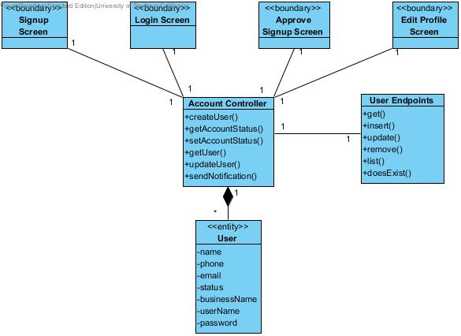 Figure 7: Design Class Diagram

Table 61: Design Class Description
Class | Type | Description
Signup Screen | Boundary | Android screen that allows users to signup for an account.
Login Screen | Boundary | Android screen that allows users to sign into their account to access the application.
Approve Signup Screen | Boundary | Android screen that allows an administrator to approve signup requests.
Edit Profile Screen | Boundary | Android screen that lets a user edit their profile.
Account Controller | Controller | This controller implements the functions associated with a user’s account.
User Endpoints | Controller | This controller is used to get, put, and update users in the Google Cloud Datastore.
User | Entity | This entity class represents a user’s account for the Construction Meeting Minutes application.

Construction Meeting Management Class Diagram
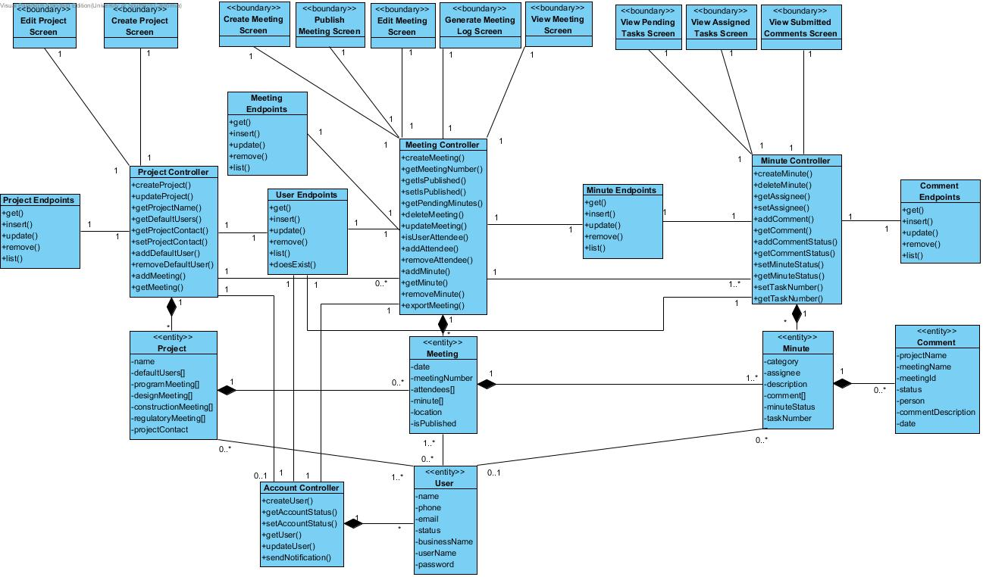 Figure 8: Meeting Management Class Diagram

Table 62: Meeting Management Class Description
Class | Type | Description
Edit Project Screen | Boundary | Android screen that allows an administrator to edit project details.
Create Project Screen | Boundary | Android screen that allows an administrator to create a new project.
Project Controller | Controller | This controller implements the functions associated with a project.
Project Endpoints | Controller | This controller is used to get, put, and update projects in the Google Cloud Datastore.
Project | Entity | This entity class represents a project for the Construction Meeting Minutes application.
Create Meeting Screen | Boundary | Android screen that lets a user edit their profile.
Publish Meeting Screen | Boundary | Android screen that allows an administrator to create a new meeting.
Edit Meeting Screen | Boundary | Android screen that allows an administrator to edit meeting details.
Generate Log Screen | Boundary | Android screen that allows an administrator to generate a meeting log in PDF form.
View Meeting Screen | Boundary | Android screen that allows a general user to view a meeting that they are an attendee to.
Meeting Controller | Controller | This controller implements the functions associated with a meeting.
Meeting Endpoints | Controller | This controller is used to get, put, and update meetings in the Google Cloud Datastore.
Meeting | Entity | This entity class represents a meeting for the Construction Meeting Minutes application.
View Pending Tasks Screen | Boundary | Android screen displays all pending tasks for the current project to an administrator.
View Assigned Tasks Screen | Boundary | Android screen displays assigned tasks to a general user.
View Submitted Comments Screen | Boundary | Android screen displays status of submitted comments to a general user.
Minute Controller | Controller | This controller implements the functions associated with a meeting minute.
Minute Endpoints | Controller | This controller is used to get, put, and update minutes in the Google Cloud Datastore.
Comment Endpoints | Controller | This controller is used to get, put, and update comments in the Google Cloud Datastore.
Minute | Entity | This entity class represents a meeting minute for the Construction Meeting Minutes application.
Account Controller | Controller | This controller implements the functions associated with a user.
User Endpoints | Controller | This controller is used to get, put, and update users in the Google Cloud Datastore.
User | Entity | This entity class represents a user for the Construction Meeting Minutes application.

Endpoints Class Diagram
Following diagram illustrates how entity objects are retrieved and stored from the Google Cloud Datastore via the Objectify API. NOTE: entity attributes are not shown in diagram for the sake of readability. Please reference previous diagrams for entity attributes.
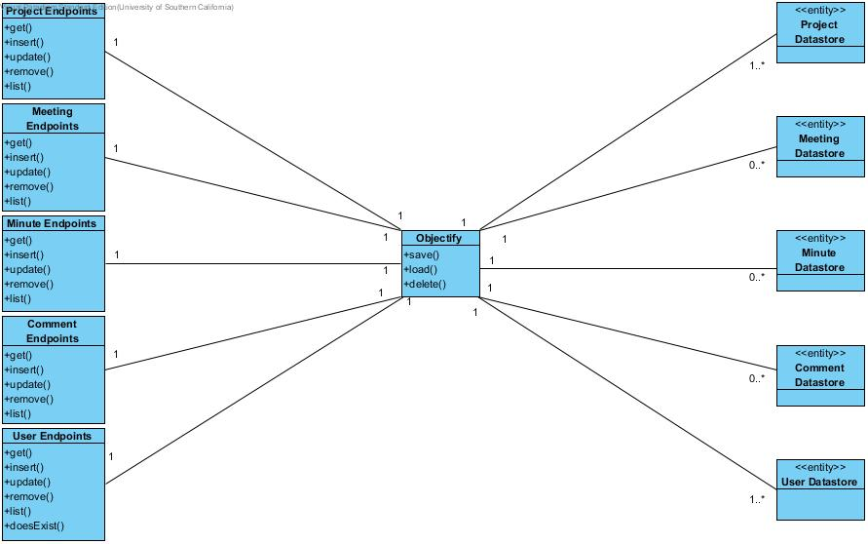 Figure 9: Endpoints Class Diagram

Table 63: Endpoints Class Description
Class | Type | Description
Project Endpoints | Controller | This controller is used to get, put, and update projects in the Google Cloud Datastore.
Meeting Endpoints | Controller | This controller is used to get, put, and update meetings in the Google Cloud Datastore.
Minute Endpoints | Controller | This controller is used to get, put, and update minutes in the Google Cloud Datastore.
Comment Endpoints | Controller | This controller is used to get, put, and update comments in the Google Cloud Datastore.
User Endpoints | Controller | This controller is used to get, put, and update users in the Google Cloud Datastore.
Objectify | Controller | This controller is the Objectify API that is used to get, put, and update entities in the Google Cloud Datastore.
Project Datastore | Entity | This entity represents a project in the Google Cloud Datastore for the Construction Meeting Minutes application.
Meeting Datastore | Entity | This entity represents a meeting in the Google Cloud Datastore for the Construction Meeting Minutes application.
Minute Datastore | Entity | This entity represents a minute in the Google Cloud Datastore for the Construction Meeting Minutes application.
Comment Datastore | Entity | This entity represents a task comment in the Google Cloud Datastore for the Construction Meeting Minutes application.
User Datastore | Entity | This entity represents a user’s account in the Google Cloud Datastore for the Construction Meeting Minutes application.

Process Realization
The following sequence diagrams illustrate how to implement their corresponding use cases. These specific cases were picked because they are core functionality that can be used as a model for other cases.
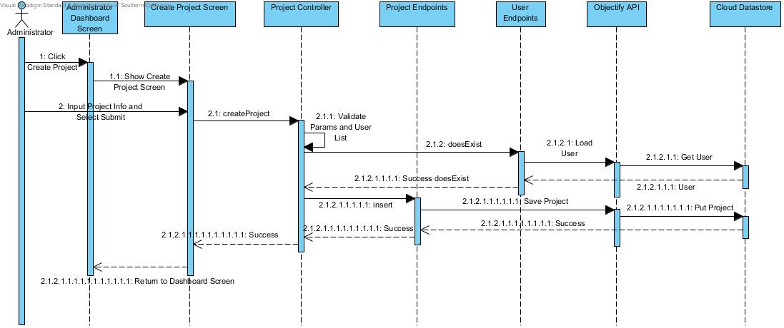Figure 10: Create New Project
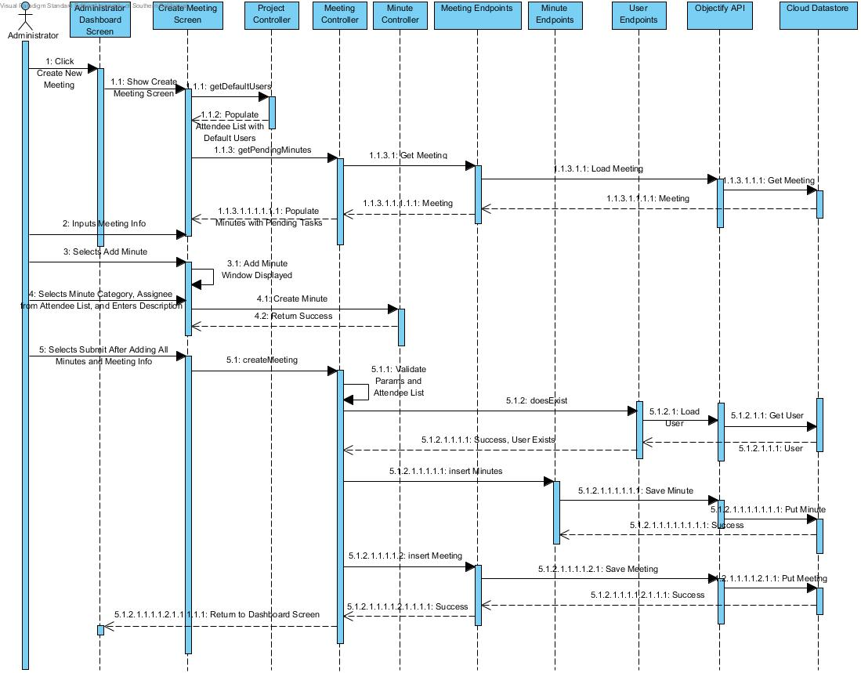Figure 11: Create New Meeting

Design Rationale
Student Scheduling System will be used by Stevens University students and staff. It must be accessible via the Internet for all users. Therefore, Student Scheduling System is designed as a web application.
The Construction Meeting Minutes Android Application will be used by the Department of Public Works to track meeting minutes and assign tasks to meeting participants. Meetings will be logged from the field using an Android device.
The Android application features a three-tier architecture pattern (see section 5 – Architectural Styles, Patterns and Frameworks). Such a design allows us to split the system up into three different parts:
- User interface
  - Android screens
- Functional logic
  - User account component
  - Project component
  - Meeting component
  - Minute component
- Data storage
  - Android Cloud Endpoints component
  - Google App Engine Server
  - Google Cloud Datastore
` The user interface, functional logic, and cloud endpoints component are native to the client Android device while the Google Cloud Datastore and Google App Engine is on a remote server. The Android Cloud Endpoints component connects to the Google App Engine program in a client-server structure. The Google App Engine backend utilizes the Objectify framework to store and retrieve data objects from the Google Cloud NoSQL Datastore. This backend storage platform was chosen because it was one of only a couple free solutions. This free solution gives our application 1GB of storage in Google Cloud’s Datastore. Android Studio IDE allows you to run and test the Google App Engine backend locally alongside your application making integration less of a challenge.

Architectural Styles, Patterns and Frameworks
Table 64: Architectural Styles, Patterns, and Frameworks
Name | Description | Benefits, Costs, and Limitations
Three-tier architecture | An architecture style in which the user interface, functional logic, and data storage are implemented and maintained as separate modules.  In the Construction Meeting Minutes Android Application, the user interface is a set of android screens while the functional logic are the controllers which manipulate the data objects. The storage is done remotely using Google Cloud’s Datastore. The Android application interfaces with the datastore through the Android Cloud Endpoints module which connects to the Google App Engine server to store and retrieve system objects (user, project, meeting, minute) from the Datastore. | Benefits:  -Adaptability: Easily allows any of the three layers to be changed easily without having much effect on the other layers.  -Maintainability: Due to the separation, any needed maintenance can be performed solely on the layer that requires it.  Costs:  -Free  Limitations:  -The application content must be viewed from the user interface tier.  -Adding new functionality likely means that all three tiers will be touched.
Client-server | Client-server is part of the three-tier architecture. For our system, Android clients running the Construction Meeting Minutes Android Application connect to a Google App Engine Server to store and retrieve data. | Benefits:  -Allows for separation of logic and storage.  -Allows multiple Android clients to store application data in a single remote location.  Costs:  -Free  Limitations:  -1GB free storage limit
Endpoints API | A remote procedure call (RPC) that provides Android clients access to remote methods. | Benefits:  -Allows you to easily generate a client library to make direct calls to the API backend.  Costs:  -Free
Google App Engine | Google App Engine is a platform as a service that allows you to build and run applications on Google’s infrastructure. | Benefits:  -Host application’s backend on Google’s high speed network without any scheduled downtime.  Costs:  -Free with limited usage
Objectify | Objectify is a Java data access API designed specifically for Google App Engine Datastore. | Benefits:  -Makes datastore easy to learn and understand.  -Provides level of abstraction that is high enough for convenience while low enough to not obscure the nature of the datastore.  Costs:  -Free  Limitations:  -Must be run on Google App Engine Platform.

